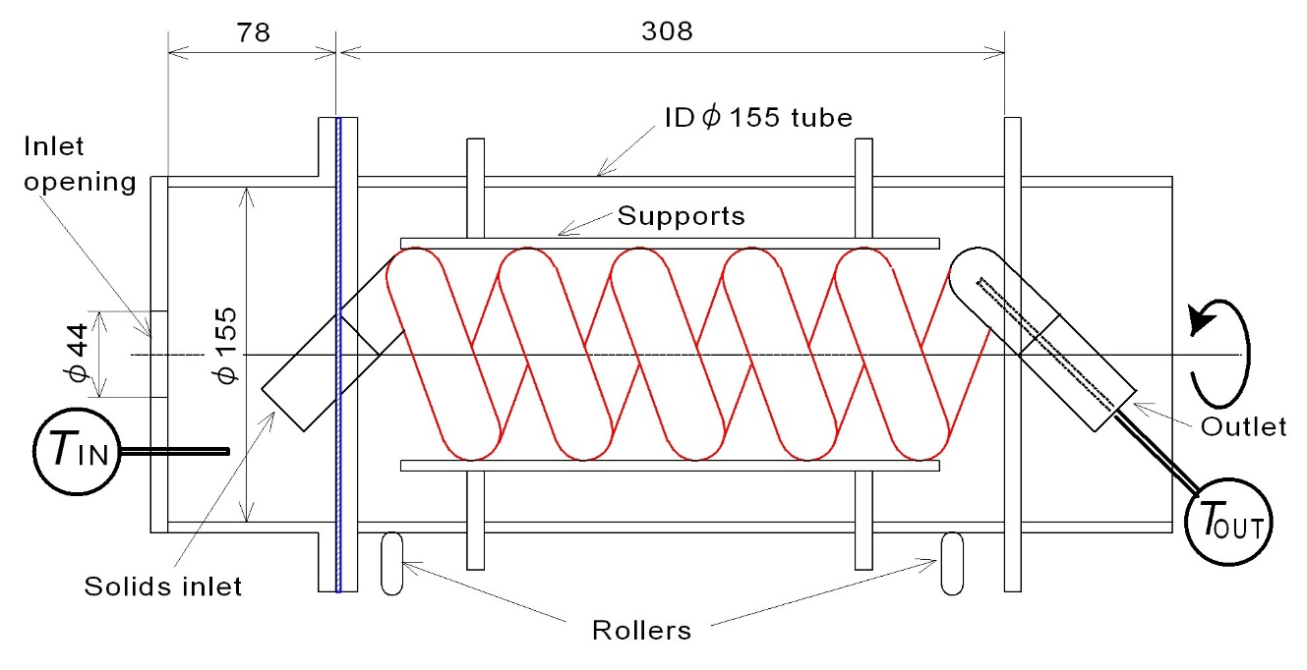

**Fig. 1** Five-cycle coil-shaped spiral rotating reactor made of 180° long elbows of JIS-20A size



**Fig. 2** Typical result of thermal diffusivity measurement of packed bed



**Fig. 3** Comparison of solid transportation rate (bulk volume per one rotation) between　present metal model and previous cold model of five-cycle coil-shaped spiral (cold model: Shimizu et al. (2019))



**Fig. 4** Relationship between rotation rate, thermal properties of particles, and wall-to-solids heat transfer coefficient.